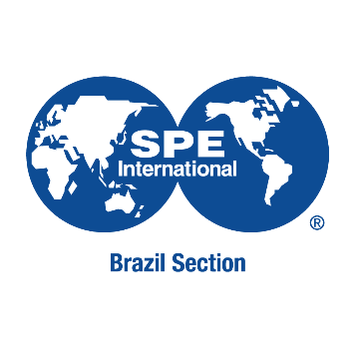
TITLE (WORK TITLE MUST BE WRITEN IN VERDANA,
FONT 12,
UPPER CASE, BOLD TYPE AND CENTER ALIGNED, NO ITALIC AND UNDERLINE TYPES)

Abstract: (225-425 words / Verdana font 11)

The Abstract must be written in such way that the reader, without reading the complete paper, may identify its content and main conclusions.
Format: Verdana font 10, single paragraph.

